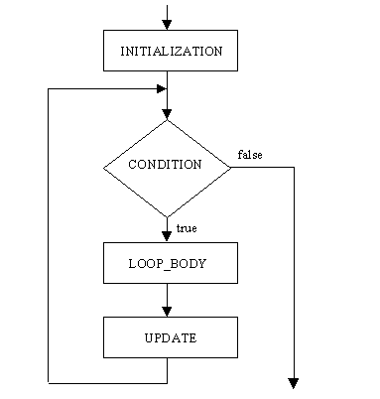Put both parts of this project in a new Eclipse project named **3E *yourLastName***

## Part I

Write a program called **Dice** that does the following:

1. Roll a pair of dice just like you did in Assignment 2H, except this time roll the dice and print the results ten times using a *for* loop.
2. Now, before the loop, ask the user for a number from the keyboard (be sure to prompt them with a message), and change the loop to repeat this many times (instead of ten times).

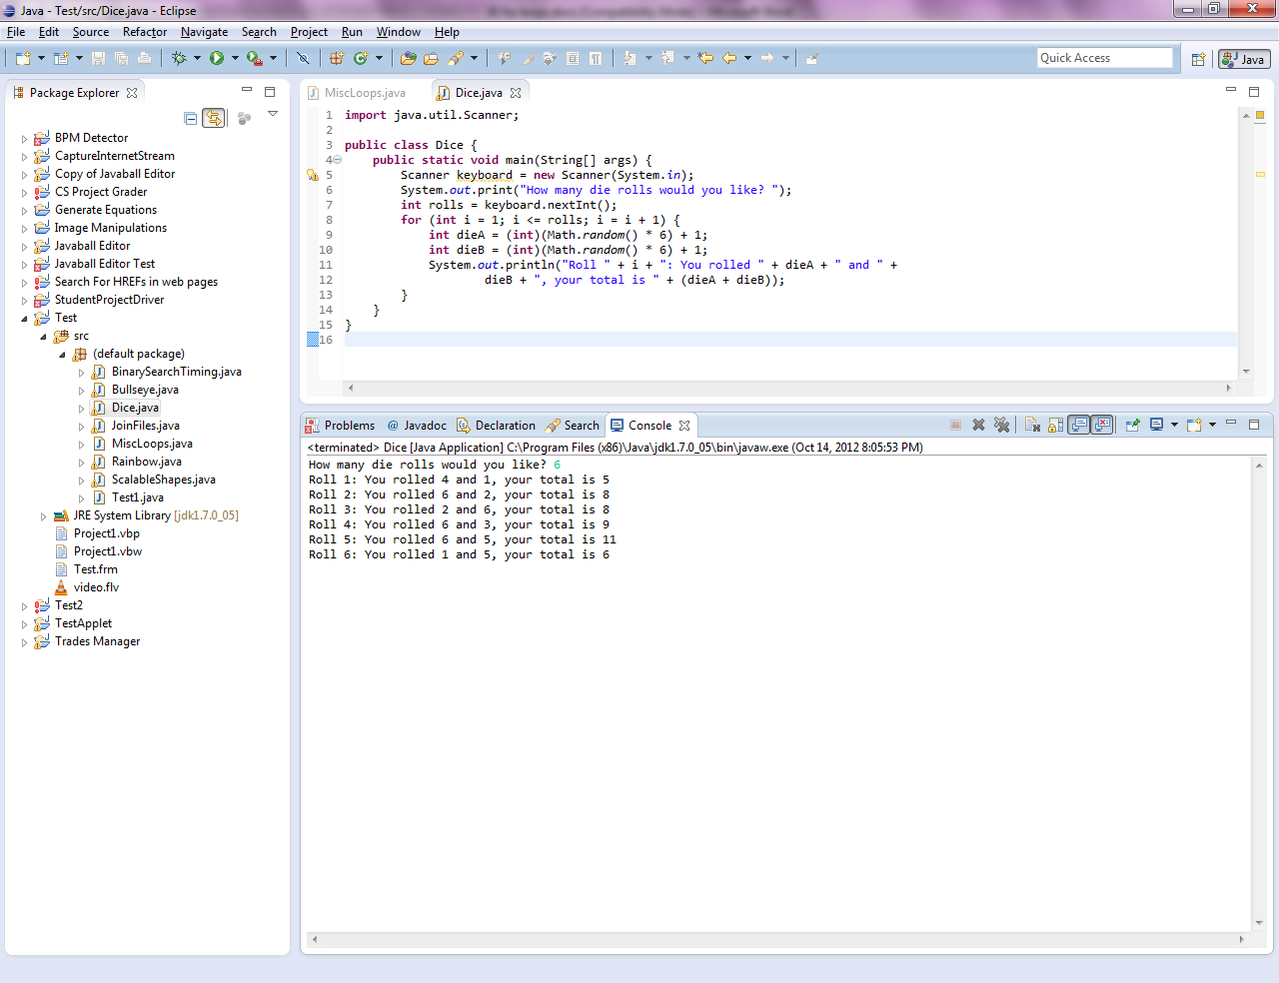The final output should look something like this (except your numbers should be different):

## Part II

Write a program called **MiscLoops** that does the following:

1. Use a *for* loop to print all the even multiples of 5 starting with 5, ending with 1000 (inclusive). Do not use “if” statements to do this, or any calculations in the loop body. Make the loop header do the work. Print all the numbers on one line, separated by a space like so::

5 10 15 20 25 30 35 40 45 50 55 60 65 70 75 80 …

1. Use a *for* loop to print the multiples of 7 in reverse order, starting with 2100 and ending with 7 (inclusive). Let the loop header do the work, rather than doing calculations in the loop body. Make sure this series of numbers prints on a fresh line, and then print a new line before starting the next part.

More on Next Page

1. Write a loop that repeats one million times (exactly). In each iteration of the loop, generate a random integer between 1 and 100,000. (Please be sure the random calculation will yield a number in *exactly* that range.) If you get the number 67,636, print a message saying “I got 67,636.” If you get any other number, don’t do anything. By the law of averages, pulling a number between one and one hundred thousand over and over again, one million times, should result in the number 67,636 getting pulled approximately ten times.

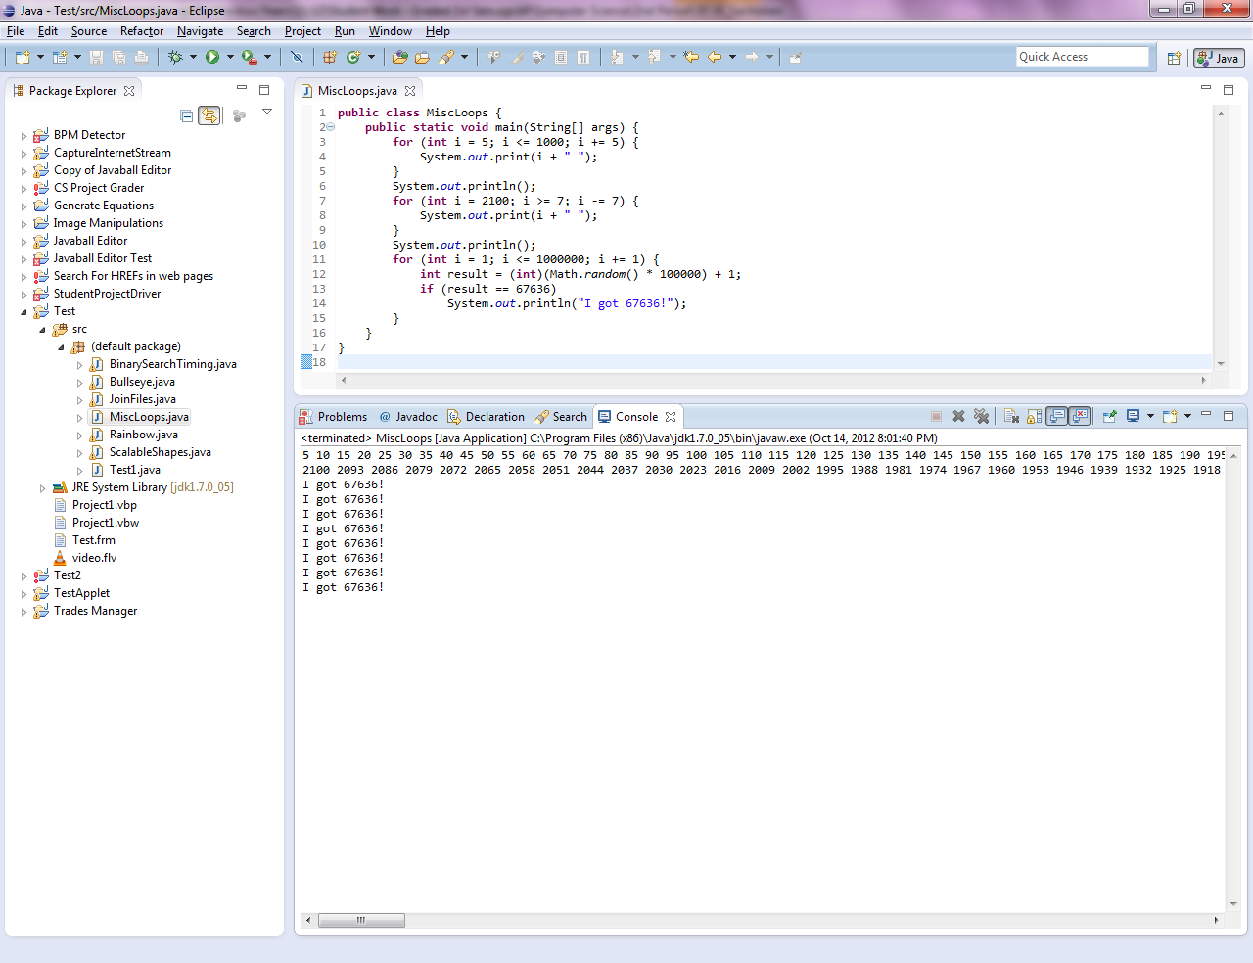The final output from part II should look like this: